Project Design Phase-II
Technology Stack (Architecture & Stack)

Date | 5 February 2026
Team ID | LTVIP2026TMIDS90283
Project Name | rising waters: a machine learning approach to flood prediction

Technical Architecture:
The Deliverable shall include the architectural diagram as below and the information as per the table1 & table 2

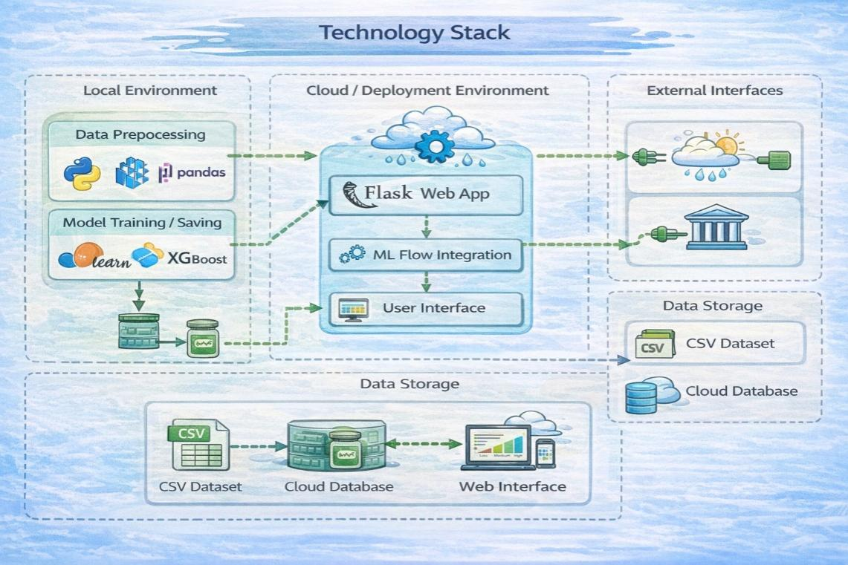

📊 Table-1: Components & Technologies

S.No | Component | Description | Technology
1 | User Interface | Web page where users enter rainfall, humidity, etc. | HTML, CSS, JavaScript
2 | Application Logic-1 | Handles user input & connects UI to backend | Flask (Python)
3 | Application Logic-2 | Data preprocessing & validation | Python (Pandas, NumPy)
4 | Application Logic-3 | Prediction logic using trained model | Scikit-learn / XGBoost
5 | Database | Stores historical flood dataset | CSV / MySQL
6 | Cloud Database | Optional storage for large datasets | IBM Cloudant
7 | File Storage | Stores trained ML model (.pkl file) | Local Storage / Cloud Storage
8 | External API-1 | Fetch live rainfall/weather data | Weather API
9 | Machine Learning Model | Predicts flood occurrence | Classification Model (Random Forest / XGBoost)
10 | Infrastructure | Deployment platform | IBM Cloud / Local Server

Table-2: Application Characteristics:

S.No | Characteristics | Description | Technology
1 | Open-Source Frameworks | Backend & ML frameworks used | Flask, Scikit-learn
2 | Security Implementations | Secure form handling & input validation | HTTPS, Flask Security
3 | Scalable Architecture | 3-tier architecture (UI, Backend, ML Model) | Flask + Cloud Deployment
4 | Availability | Deployed on cloud for 24/7 access | IBM Cloud
5 | Performance | Lightweight model for fast prediction | Optimized ML Model

